**K L UNIVERSITY ARTIFICIAL INTELLIGENCE AND DATA SCIENCE**

**DEPARTMENT**

**A Midgrade Capstone Project Report**

**On**

## **VISUAL TRACKING FOR TRAFFIC MANAGEMENT SYSTEM**

## **SUBMITTED BY:**

**ID.NUMBER NAME**

2000080098 SUMEET SEKHAR

2000080134 CHAKRADHAR MYNAM

2000089003 SANHITH CHINTALA

**UNDER THE ESTEEMED GUIDANCE OF**

**MRS.V.LAKSHMI LALITHA**

## Department of Artificial Intelligence & Data Science

K L E F, Green Fields,

Vaddeswaram- 522502, Guntur(Dist), Andhra Pradesh, India.

November,2022



### 1

# Declaration

The Project Report entitled Visual Tracking For Traffic Management System is a record of bonafide work of 2000080098, 2000080134, 2000089003 submitted in partial fulfillment for the award of B.Tech in Artificial Intelligence and Data Science to the K L University. The results embodied in this report have not been copied from any other departments/University/Institute.

Project Members: -

2000080098 – SUMEET SEKHAR

2000080134 – CHAKRADHAR MYNAM

2000089003– SANHITH CHINTALA

**2**

# DEPARTMENT OF ARTIFICIAL INTELLIGENCE & DATA SCIENCE

# 

CERTIFICATE

This is to certify that the Project Report entitled **VISUAL TRACKING FOR TRAFFIC MANAGEMENT SYSTEM** is being submitted by 2000080098-SUMEET SEKHAR 2000080134- CHAKRADHAR MYNAM, 2000089003-SANHITH CHINTALA submitted to the **Department of Artificial intelligence and Data Science, KL University** in partial fulfilment of the requirements for the completion of a project for **“MID GRADE CAPSTONE -2”** course in 3rd B Tech 6th Semester, is a Bonafede record of the work carried out by him/her under my supervision during the academic year 2022 – 2023.

**HEAD OF THE DEPARTMENT PROJECT SUPERVISOR**

**DR GANDHARBA SWAIN MRS. V. LAKSHMI LALITHA**

**3**

# Acknowledgments

It is a great pleasure for me to express my gratitude to our honorable President Sri. Koneru Satyanarayana, for giving the opportunity and platform with facilities in accomplishing the project-based laboratory report.

I express sincere gratitude to our Director Dr. A. Jagdeesh for his administration towards our academic growth.

I express sincere gratitude to our HOD-AI&DS Dr. GANDHARBA SWAIN for his leadership and constant motivation provided in successful completion of our academic semester. I record it as my privilege to deeply thank you for providing us the efficient faculty and facilities to make our ideas into reality.

I express my sincere thanks to our project supervisor MRS. V. LAKSHMI LALITHA for her novel association of ideas, encouragement, appreciation and intellectual zeal which motivated us to venture this project successfully.

Finally, we are pleased to acknowledge the indebtedness to all those who devoted themselves directly or indirectly to making this project report success.

Project Members: -

2000080098 – SUMEET SEKHAR

2000080134 – CHAKRADHAR MYNAM

2000089003– SANHITH CHINTALA

**4**

# INDEX

|  |  |  |
| --- | --- | --- |
| **S.NO** | **TITLE** | **PAGE NO** |
| 1 | Abstract | 6 |
| 2 | Introduction | 7-10 |
| 3 | Literature Survey | 11-13 |
| 4 | Theoretical Analysis | 14-24 |
| 5 | Experimental Investigations | 25-34 |
| 6 | Experimental Results | 35 |
| 7 | Discussions of Results | 36 |
| 8 | Conclusion | 36 |
| 9 | Summary | 37 |
| 10 | References | 38-39 |

# 

**5**

**I. ABSTRACT**

Due to the increase in population, the number of vehicles is increasing rapidly. Increase in vehicles leads to many traffic problems like traffic jams, accidents, money loss, wastage of time, pollution, health problems and many more. So, it is necessary to manage and control traffic. Various traffic management techniques are used, each having its own advantages and disadvantages. Currently used techniques are not so efficient in terms of performance, cost, maintenance etc. In this paper, we will discuss traffic management systems based on Digital Image Processing. Use of digital image processing will help with better traffic management and it is cost effective.

**KEYWORDS:** Bounding Box ,scales prediction ,recognition, integration , YOLO V3, traffic monitoring, Computer vision, open cv.

#### Contributions of each Team Member:-

2000080098-SUMEET SEKHAR- Introduction, Literature Survey. 2000080134- CHAKRADHAR MYNAM- Abstract, Methodology.

2000089003-SANHITH CHINTALA- Problems Identified, Solution, Future Goals.

**6**

# II. INTRODUCTION

**Problem Statement: -**

**VISUAL TRACKING FOR TRAFFIC MANAGEMENT SYSTEM**

Visual tracking system is one of the principals in computer Vision, where estimation of a targeted object is done. Usually, a certain object idestimated out in all frames of a video.

Video tracking is an application of object tracking where moving objects are located within video information. Hence, video tracking systems can process live, real- time footage and also recorded video files.

There are two types of visual tracking, usually CATEGORY TRACKING AND GENERIC OBJECT TRACKING. In category tracking, tracking is done based on a specific category. In this we would be able to train out so that classifier can distinguish a specific category of object from background pixels. generic object tracking.

In today’s world, where technology has transcended all barriers, it has now become easy to solve most human problems and one of these problems includes traffic congestion. Traffic congestion has increased drastically over the years and has had negative impacts that include road rage, accidents, air pollution, wastage of fuel and most importantly unnecessary delays. One of the many causes of traffic congestion is improper traffic management systems.

Traffic Management refers to the combination of measures that serve to preserve traffic capacity and improve the security, safety and reliability of the overall road transport system. These measures make use of ITS systems, services and projects in day-to-day operations that impact on road network performance.

**7**

Central to this approach is the development and integration of a set of traffic management measures appropriate to the local and regional requirements – and to achieve this through a planning process that makes use of systems engineering, standardization and documentation, and performance management.

The main purpose of this paper is to introduce a system which will allot time to each road based on the amount of traffic. vehicle detection and counting are becoming increasingly important in the field of highway management. However, due to the different sizes of vehicles, their detection remains a challenge that directly affects the accuracy of vehicle counts.

To address this issue, this paper proposes a vision-based vehicle detection and counting system. With the popular installation of traffic surveillance cameras, a vast database of traffic video footage has been obtained for analysis.

Generally, at a high viewing angle, a more-distant road surface can be considered.

The object size of the vehicle changes greatly at this viewing angle, and the detection accuracy of a small object far away from the road is low.

This traffic management system fulfills its duty by enabling the smooth movement of vehicles and it also has a fail-safe system which will prove useful in unexpected circumstances.

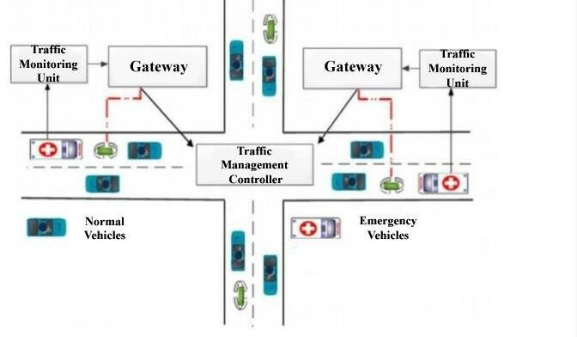

# Fig.1

**8**

### II.I Introduction to Machine Learning:

There is a growing misconception that deep learning is a competitive technology in machine learning domain. In this article, we discuss some of these myths and explain how deep learning is related to machine learning and the advantages of using deep learning algorithms in certain applications.

To put things in perspective, deep learning is a subdomain of machine learning. With accelerated computational power and large data sets, deep learning algorithms can self-learn hidden patterns within data to make predictions.

In essence, you can think of deep learning as a branch of machine learning that's trained on large amounts of data and deals with many computational units working in tandem to perform predictions.

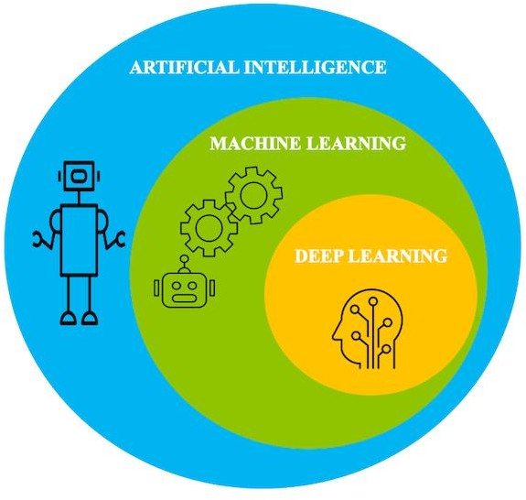

**Fig.2**

**9**

Machine learning works only with sets of structured and semi-structured data, while deep learning works with both structured and unstructured data

Deep learning algorithms can perform complex operations efficiently, while machine learning algorithms cannot.

Machine learning algorithms use labelled sample data to extract patterns, while deep learning accepts large volumes of data as input and analyses the input data to extract features out of an object.

The performance of machine learning algorithms decreases as the amount of data increases; so to maintain the performance of the model, we need a deep learning.

To create systems that learn similar to how humans learn, the underlying architecture for deep learning was inspired by the structure of a human brain. For this reason, quite a few fundamental terminologies within deep learning can be mapped back to neurology. Similar to how neurons form the fundamental building blocks of the brain, deep learning architecture contains a computational unit that allows modelling of nonlinear functions called *perceptron*.

The magic of deep learning starts with the humble perceptron. Similar to how a "neuron" in a human brain transmits electrical pulses throughout our nervous system, the perceptron receives a list of input signals and transforms them into output signals.

The perceptron aims to understand data representation by stacking together many layers, where each layer is responsible for understanding some part of the input. A layer can be thought of as a collection of computational units that learn to detect a repeating occurrence of values.

Each layer of perceptron is responsible for interpreting a specific pattern within the data. A network of these perceptron mimics how neurons in the brain form a network, so the architecture is called neural networks (or artificial neural networks).

**10**

# 

# III. LITERATURE SURVEY

### III.I Importance of Image Processing:

Image processing is a method to perform some operations on an image, in order to get an enhanced image or to extract some useful information from it. It is a type of signal processing in which input is an image and output may be image or characteristics/features associated with that image. Nowadays, image processing is among rapidly growing technologies. It forms core research area within engineering and computer science disciplines too.

Image processing basically includes the following three steps:

* + - Importing the image via image acquisition tools.
    - Analyzing and manipulating the image.
    - Output in which result can be altered image or report that is based on image analysis.

There are two types of methods used for image processing namely, analogue and digital image processing. Analogue image processing can be used for hard copies like printouts and photographs. Image analysts use various fundamentals of interpretation while using these visual techniques. Digital image processing techniques help in manipulation of digital images by using computers. The three general phases that all types of data must undergo while using digital technique are pre-processing, enhancement, display, information extraction.

In this lecture we will talk about a few fundamental definitions such as image, digital image, and digital image processing. Different sources of digital images will be discussed and examples for each source will be provided. The continuum from image processing to computer vision will be covered in this lecture. Finally, we will talk about image acquisition and different types of image sensors.

The History of Traffic Management System started in 1972 to centrally control the freeway system in the Twin Cities metro area. The Traffic Management System aims to provide motorists with a faster, safer trip on metro area freeways by optimizing the use of available freeway capacity, efficiently managing incidents and special events, providing traveler information, and providing incentives for ride sharing.

**11**

Transportation and property are important in physical and economic development of towns and cities all over the world.

Property and land values tend to increase in areas with expanding transportation networks and increase less rapidly in areas without such improvements.

Rapid and continued rise in housing and land prices are expected in cities. with transportation improvements and rapid economic and population growth. Road networks are observed in terms of its components of accessibility, connectivity and Traffic density, level of service, compactness, and density of particular roads. Level of service is a measure by which the quality of service on transportation devices or infrastructure is determined, and it is a holistic approach considering several factors regarded as measures of traffic density and congestion rather than overall speed of the journey.

This paper uses a combination of techniques so as to provide results that are more accurate. Vehicle-based illustrates the characteristic of using some kind of devices installed in vehicles to locate its position using different methods of realizing and identifying. The three popular applications are Global Positioning System (GPS), Transponders, and Wireless Phones. Global Positioning Systems use earth-orbiting satellites to obtain the global map and locate position of all vehicles with GPS box installed. The second approach using Transponders which are some kinds of vehicle tags that left inside the car and using synchronous data signal between the vehicles and the controllers on the transport infrastructure to recognize the occupation of the vehicle on the roads. The last method using Wireless Phones to send and receive traffic information from the Transportation Management Center (TMC) to notify the drivers about the neighboring traffic condition for efficient driving. All these methods are proven to produce high accuracy and fast data speed, but they all require vehicle owner to invest an initial capital to install one of those devices in their vehicles. That creates firstly a barrier for drivers with low budget, and second the privacy threats for those who do install one of those devices in their vehicles, since all the information is frequently and automatically sent to the database server. [2nd Int. Conf. on Computer Technology and Development, Cairo, Nov 2010, pp].

**12**

Among various emerging ICT fields, there exists a subfield called Computer Vision, which has existed for more than thirty years, but only recently that it is considered as a formal research area, thanks to the emergence of fast computer processors. The main objectives of Computer Vision are to learn ways of perceiving the world through graphical representation.

Two main research areas of Computer Vision are in Robotics and Traffic Surveillance, where there normally exist some kinds of cameras that take the snapshot of the real world, and only by looking those images, there can be derived different information which is helpful to autonomously control an operation. Some famous applications of Computer Vision can be seen in face detection, image segmentation, 3D scene reconstruction, and general pattern recognition techniques. The employment of Computer Vision in traffic surveillance helps to reduce the implementation cost by reusing the roadside CCTV cameras installed on the road.

In addition, by modeling the real traffic system, the information comprehensive to the machine includes all that are desirable for human purposes, for example, the position of the vehicles on the lanes, their speeding status, and their travel trajectory.

**13**

# IV.THEORETICAL ANALYSIS

### IV.I Traffic Dataset Description: -

Traffic congestion has been one of the fundamental problems faced by modern cities since the wide usage of automobiles. Just a normal few minute’s trip to the convenience store may take up to half an hour due to traffic jams or slowdown. According to the police, congestion is the cause of some issues like road rage, road bullies and major accidents.

The small road capacity is also one of the contributing factors. As the number of private cars increases greatly over the years, traffic congestion occurs when the needed road capacity is not fulfilled. Simple improvements of the road infrastructure can easily solve this problem. Since congestion occurs frequently in the cities, local government municipal can consider passing laws restricting the number of cars owned in a family. This method is in fact workable and effective.

**IV.II. Existing system proposed to track traffic and managing of traffic systems:-**

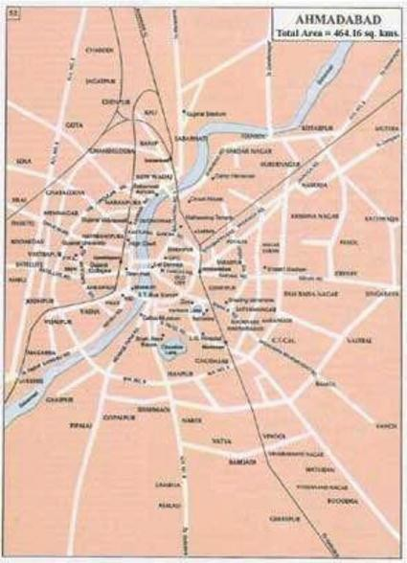

# Fig.3

**14**

First, it is necessary to have monitoring tools for measuring traffic conditions in the city. In this program, we installed traffic video monitoring cameras shown in Figure 3. This is a general camera in the traffic industry. And the special high resolution 4 K camera is installed at the major junction—Plaid junction as detail analysis at junction.

**Table.1**

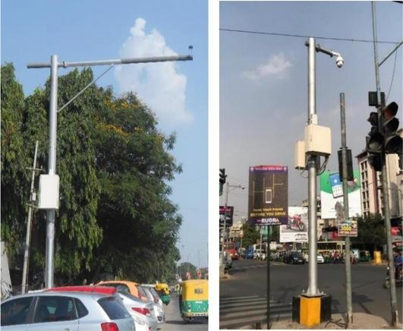

**Fig.4**

**15**

Second, the total number of cameras is 36 including 4 K cameras. The camera location is shown in Figure 5 (The number is camera ID, and 4 K camera has no number, but it is in the center among 2000s ID cameras in the map). The traffic video camera has several functions such as counting number of vehicles on the road, average vehicle speed, traffic density, occupancy and so on. Traffic density is the number of vehicles per kilometer on the road (vehicle/km) which is defined in the traffic flow theory. Occupancy is how much percentage occupied by vehicles on the road which is also defined in the traffic flow theory. The detailed parameter explanation is described in later of this chapter.

**Fig.5**

Third, here is an example of traffic condition data which is shown in Figure 6. There are two graphs shown which are time-based traffic volume and average vehicle speed. From those graphs. we see the traffic condition (in this case camera #2 location). It is clear that the traffic congestion occurred around 20:00 o’clock because its traffic volume was peak and average vehicle speed is lowest. The data here is a month data in June 2019 and each graph shows average point and standard deviation.

**16**

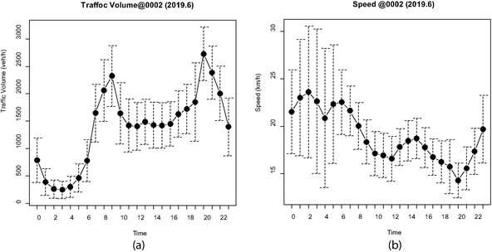 **Fig.6**

clear that the traffic congestion occurred around 20:00 o’clock because its traffic volume was peak and average vehicle speed is lowest. The data here is a month data in June 2019 and each graph shows average point and standard deviation.

#### IV.III.PROPOSED METHODOLOGY TO TRACK TRAFFIC MANAGEMENT SYSTEM: -

**IV.III.I Classification of Vehicles:-**

The Federal Highway Administration [(FHWA) recommends](http://www.fhwa.dot.gov/ohim/tmguide/tmg4.htm#chap5) that highway agencies use the 13-Category Scheme to classify vehicles. TxDOT uses the FHWA scheme for its manual vehicle classification program, and it is essential that traffic counters classify vehicles accurately in accordance with this scheme.

The [FHWA 13-Category Scheme](http://www.fhwa.dot.gov/ohim/tmguide/tmg4.htm#app4c) is separated into categories depending on whether the vehicle carries passengers or commodities. Non-passenger vehicles are further subdivided by the number of axles and number of units, including both power and trailer units. Note that the addition of a trailer to vehicle classes 1 to 5 does not change the classification of the vehicle.

**17**

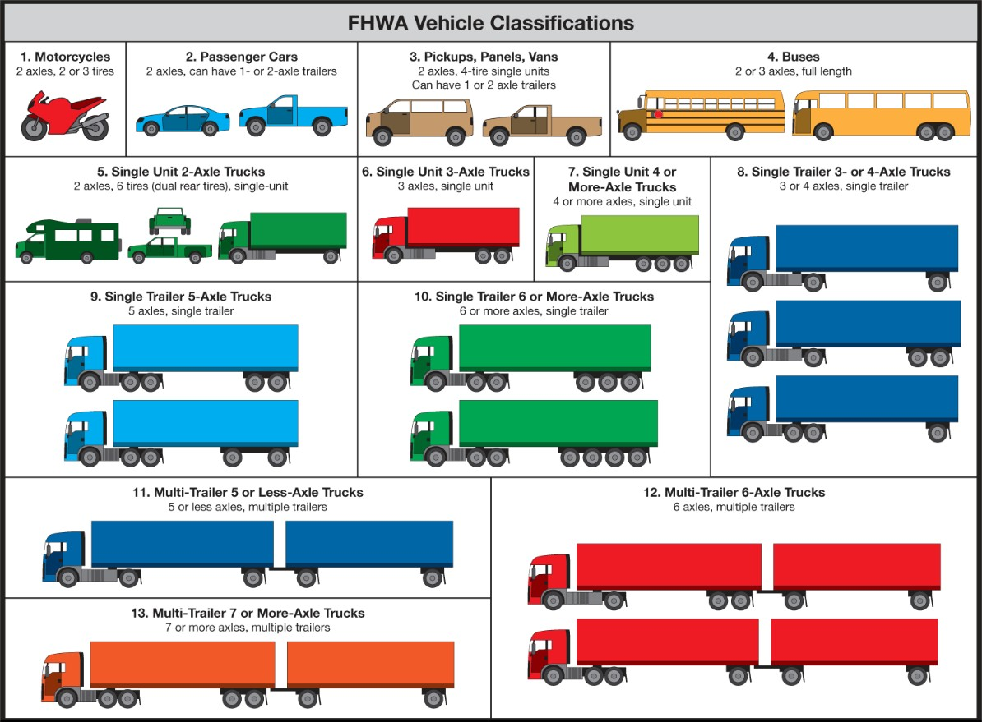

**Fig.7**

**Table.2**

**18**

**Table.3**

#### IV.III.II.BOUNDING BOX :

Bounding boxes are one of the most popular—and recognized tools when it comes to image processing for image and video annotation projects.Image processing techniques is one of the main reasons why computer vision continues to improve and drive innovative AI-based technologies.

From self-driving cars to facial recognition technology—computer vision applications are the face of new image segmentation in image processing era.

A bounding box is an imaginary rectangle that serves as a point of reference for object detection and creates a collision box for that object in projects on image processing.

Data annotators draw these rectangles over machine learning images, outlining the object of interest within each image by defining its X and Y coordinates. This makes it easier for machine learning algorithms to find what they’re looking for, determine collision paths, and conserves valuable computing resources.

Bounding boxes or rotating bounding boxes are one of the most popular image annotation techniques in deep learning. Compared to other image segmentation processing methods, this method can reduce costs and increase annotation efficiency.

**19**

#### Using Bounding Boxes for Object Detection

But how does object detection work in relation to bounding boxes? How does this type of image annotation work? Answering this question requires looking at object detection as two components: object classification and object localization.

In other words, to detect and target an object in an image, artificial intelligence needs to know what it is and where it is during machine learning image processing.

Take self-driving cars as an example. An annotator will draw bounding boxes around other vehicles and label them. This helps train an algorithm of computer vision models to understand what vehicles look like. Annotating objects such as vehicles, traffic signals, and pedestrians makes it possible for autonomous vehicles to maneuver busy streets safely. Self-driving car perception models rely heavily on bounding boxes to make this possible.

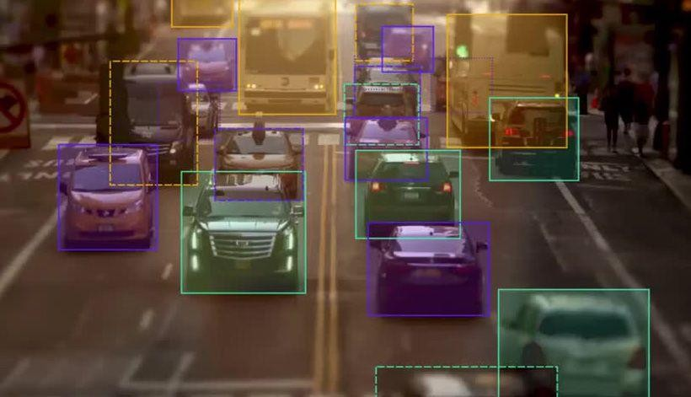

**Fig.8**

However, it’s important to note that a single bounding box doesn’t guarantee a perfect high level prediction rate. Enhanced object detection requires many bounding boxes in combination with data augmentation techniques.

**20**

#### Common Use Cases for Bounding Boxes

There are a variety of use cases for image processing and bounding boxes. Some of the more popular ones include:

* Self-driving cars
* Insurance claims
* Ecommerce
* Agriculture
* Healthcare

Bounding boxes are used in all of these areas as basic image annotation tool. It is used to train algorithms to identify patterns. An insurance company may leverage machine learning and training data to document insurance claims for car accidents, while an agriculture company could use it to identify what stage of growth a plant is in.

#### Classification:

In classification or class prediction, we try to use the information from the predictors or independent variables to sort the data samples into two or more distinct classes or buckets. Classification is the most widely used data mining task in business. There are several ways to build classification models. In this chapter, we will discuss and show the implementation of six of the most used classification algorithms: decision trees, rule induction, k-nearest neighbors, naïve Bayesian, artificial neural networks, and support vector machines.

Classification is a task that requires the use of machine learning algorithms that learn how to assign a class label to examples from the problem domain. An easy-to-understand example is classifying emails as “spam” or “not spam.”

There are many different types of classification tasks that you may encounter in machine learning and specialized approaches to modeling that may be used for each.

**21**

Classification predictive modeling involves assigning a class label to input examples.

Binary classification refers to predicting one of two classes and multi-class classification involves predicting one of more than two classes.

Multi-label classification involves predicting one or more classes for each example and imbalanced classification refers to classification tasks where the distribution of examples across the classes is not equal.

There are many different types of classification algorithms for modeling classification predictive modeling problems.

There is no good theory on how to map algorithms onto problem types; instead, it is generally recommended that a practitioner use controlled experiments and discover which algorithm and algorithm configuration results in the best performance for a given classification task.

Classification predictive modeling algorithms are evaluated based on their results. Classification accuracy is a popular metric used to evaluate the performance of a model based on the predicted class labels. Classification accuracy is not perfect but is a good starting point for many classification tasks.

Instead of class labels, some tasks may require the prediction of a probability of class membership for each example. This provides additional uncertainty in the prediction that an application or user can then interpret. A popular diagnostic for evaluating predicted probabilities is the ROC Curve . There are perhaps four main types of classification tasks that you may encounter; they are:

* Binary Classification
* Multi-Class Classification
* Multi-Label Classification
* Imbalanced Classification

**22**

The **Model for Prediction Across Scales** (**MPAS**) is a coupled Earth system modeling package that integrates [atmospheric,](https://en.wikipedia.org/wiki/Atmospheric_model) oceanographic and cryospheric modeling on a variety of scales from the [planetary](https://en.wikipedia.org/wiki/General_Circulation_Model) to regional and mesoscale/microscale. It includes [climate](https://en.wikipedia.org/wiki/Climate_model) and [weather](https://en.wikipedia.org/wiki/Numerical_weather_prediction) modeling and simulations that were first used by researchers in 2013.[[1]](https://en.wikipedia.org/wiki/Model_for_Prediction_Across_Scales#cite_note-1) The atmospheric components (MPAS-A) were led by the [National Center for Atmospheric Research](https://en.wikipedia.org/wiki/National_Center_for_Atmospheric_Research) (NCAR)'s Earth System Laboratory (NESL) and the oceanographic components (MPAS-O) by the Climate, Ocean, and Sea Ice Modeling Group (COSIM) at [Los Alamos National](https://en.wikipedia.org/wiki/Los_Alamos_National_Laboratory)

[Laboratory](https://en.wikipedia.org/wiki/Los_Alamos_National_Laboratory) (LANL).[[2]](https://en.wikipedia.org/wiki/Model_for_Prediction_Across_Scales#cite_note-2) It has been used for real-time weather as well as

seasonal [forecasting](https://en.wikipedia.org/wiki/Forecasting) of [convection,](https://en.wikipedia.org/wiki/Atmospheric_convection) [tornadoes[3]](https://en.wikipedia.org/wiki/Tornado) and [tropical cyclones](https://en.wikipedia.org/wiki/Tropical_cyclone)[,[4]](https://en.wikipedia.org/wiki/Model_for_Prediction_Across_Scales#cite_note-4) among other uses. Its atmospheric modeling aspects are intended to use[[5]](https://en.wikipedia.org/wiki/Model_for_Prediction_Across_Scales#cite_note-NCAR_2014-5) and complement rather than replace the [Weather Research and Forecasting Model](https://en.wikipedia.org/wiki/Weather_Research_and_Forecasting_Model) (WRF-ARW/NMM),

the [Global Forecast System](https://en.wikipedia.org/wiki/Global_Forecast_System) (GFS) and the [Community Earth System Model](https://en.wikipedia.org/wiki/Community_Earth_System_Model) (CESM).

**23**

#### FEATURE EXTRACTOR: -

Feature extraction for image data represents the interesting parts of an image as a compact feature vector. In the past, this was accomplished with specialized feature detection, feature extraction, and feature matching algorithms. Today, deep learning is prevalent in image and video analysis, and has become known for its ability to take raw image data as input, skipping the feature extraction step.

Regardless of which approach you take, computer vision applications such as image registration, object detection and classification, and content-based image retrieval, all require effective representation of image features – either implicitly by the first layers of a deep network, or explicitly applying some of the longstanding image feature extraction techniques.

#### Detecting an object (left) in a cluttered scene (right) using a combination of feature detection, feature extraction, and matching. See example for details.

**Fig.9**

Feature extraction techniques provided by Computer Vision Toolbox™ and Image Processing Toolbox™ include:

Histogram of oriented gradients (HOG) Speeded-up robust features (SURF) Local binary pattern (LBP) features.

**24**

# 

# V.EXPERIMENTAL INVESTIGATIONS

Traffic monitoring through computer vision systems allows solving tasks like vehicle counting, accident detection, roundabout entry/exit analysis, or assisted traffic surveillance. The goal of a traffic monitoring system is to provide a 5 framework to detect the vehicles that appear on a video image and estimate their position while they remain on the scene. A complete traffic monitoring application requires the integration between detection and tracking. Besides, in real-life traffic scenarios, two requirements are especially important: occlusion handling and real-time performance, especially when there are many vehicles on 10 the scene.

From the computer vision point of view, we can distinguish two different approaches for tracking: low-level and high-level tracking. In this work, we consider low-level trackers, those algorithms that, once initiated with a detection bounding box, estimate the position of the object in the new frame exploiting 15 just the visual information.

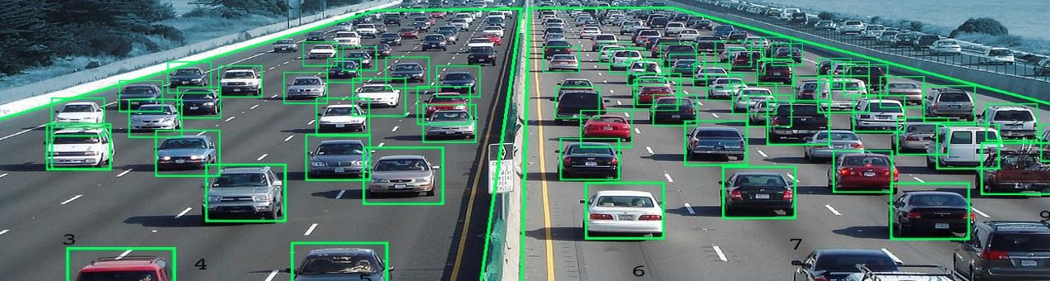

# 25

# 

**V.I.Tools used in the project:-**

**OpenCV:**

OpenCV (Open-Source Computer Vision Library) is an open-source computer vision and machine learning software library.

OpenCV was built to provide a common infrastructure for computer vision applications and to accelerate the use of machine.

perception in the commercial products. Being an Apache 2 licensed product, OpenCV makes it easy for businesses to utilize and modify the code.

The library has more than 2500 optimized algorithms, which includes a comprehensive set of both classic and state-of-the-art computer vision and machine learning algorithms.

**26**

These algorithms can be used to detect and recognize faces, identify objects, classify human actions in videos, track camera movements, track moving objects, extract 3D models of objects, produce 3D point clouds from stereo cameras, stitch images together to produce a high resolution image of an entire scene, find similar images from an image database, remove red eyes from images taken using flash, follow eye movements, recognize scenery and establish markers to overlay it with augmented reality, etc.

OpenCV has more than 47 thousand people in the user community and an estimated number of downloads exceeding 18 million. The library is used extensively in companies, research groups and by governmental bodies.

Along with well-established companies like Google, Yahoo, Microsoft, Intel, IBM, Sony, Honda, Toyota that employ the library, there are many startups such as Applied Minds, VideoSurf, and Zeitera, that make extensive use of OpenCV. OpenCV’s deployed uses span the range from stitching Streetview images together, detecting intrusions in surveillance video in Israel, monitoring mine equipment in China, helping robots navigate and pick up objects at Willow Garage, detection of swimming pool drowning accidents in Europe, running interactive art in Spain and New York, checking runways for debris in Turkey, inspecting labels on products in factories around the world on to rapid face detection in Japan.

It has C++, Python, Java, and MATLAB interfaces and supports Windows, Linux, Android, and Mac OS. OpenCV leans mostly. Towards real-time vision applications and takes advantage of MMX and SSE instructions when available. Full-featured CUDA and OpenCL interfaces are being actively developed right now. There are over 500 algorithms and about 10 times as many functions that compose or support those algorithms. OpenCV is written natively in C++ and has a templated interface that works seamlessly with STL containers.



**27**

**YOLO V3: -**

YOLOv3 (You Only Look Once, Version 3) is a real-time object detection algorithm that identifies specific objects in videos, live feeds, or images. The YOLO machine learning algorithm uses features learned by a deep convolutional neural network to detect an object. Versions 1-3 of YOLO were created by Joseph Redmon and Ali Farhadi, and the third version of the YOLO machine learning algorithm is a more accurate version of the original ML algorithm. The first version of YOLO was created in 2016, and version 3, which is discussed extensively in this article, was made two years later in 2018. YOLOv3 is an improved version of YOLO and YOLOv2. YOLO is implemented using the Kera’s or OpenCV deep learning libraries. The official successors of YOLOv3 are YOLOv4, and the newly released YOLOv7, which marks the current state-of-the-art object detector in 2022.

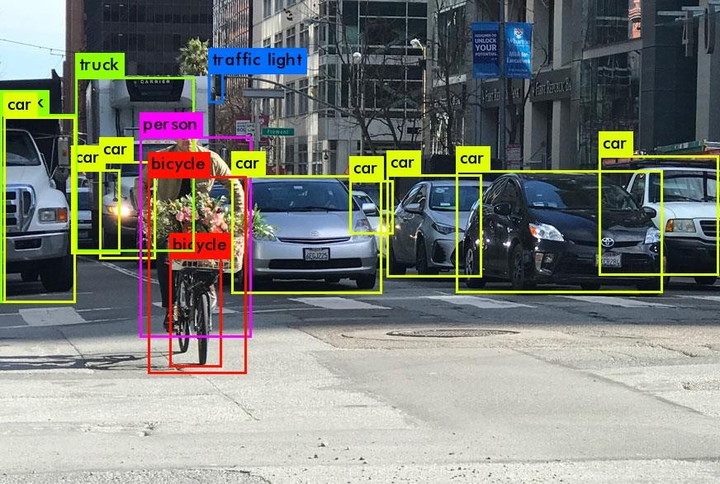

**28**

### V.I.Steps involved in the project:-

### IMPORTING: -

#### #Step 1: Import the required packages

from keras.models import Sequential from keras.layers import Conv2D

from keras.layers import MaxPooling2D from keras.layers import Flatten

from keras.layers import Dense from keras.utils import plot_model **# Step 2: Initialising the CNN** model = Sequential()

'''

#### # Step 3: Convolution

model.add(Conv2D(8, (3, 3), input_shape = (64, 64, 3), activation = 'relu'))

model.add(Conv2D(16, (3, 3), activation = 'relu'))

model.add(Conv2D(32, (3, 3), activation = 'relu'))

model.add(Conv2D(64, (3, 3), activation = 'relu'))

model.add(MaxPooling2D(pool_size = (8, 8))) model.add(Conv2D(128,(3, 3), activation = 'relu')) '''

model.add(Conv2D(32, (3, 3), input_shape = (64, 64, 3), activation = 'relu'))

#### # Step 4: Pooling

model.add(MaxPooling2D(pool_size = (2, 2)))

#### # Step 5: Second convolutional layer

model.add(Conv2D(32, (3, 3), activation = 'relu'))

model.add(MaxPooling2D(pool_size = (2, 2)))

#### # Step 6: Flattening

#### model.add(Flatten())

#### 29

#### # Step 7: Full connection

model.add(Dense(units = 128, activation = 'relu')) model.add(Dense(units = 1, activation = 'sigmoid'))

**# Step 8: Compiling the CNN**

model. Compile(optimizer = 'adam', loss 'binary_crossentropy', metrics = ['accuracy'])

#### # Step 9: ImageDataGenerator

from keras.preprocessing.image import ImageDataGenerator

train_datagen = ImageDataGenerator(rescale = 1./255,

shear_range = 0.2,

zoom_range = 0.2,

horizontal_flip = True)

#### # Step 10: Load the training Set

training_set = train_datagen.flow_from_directory('./training_set',

target_size = (64, 64),

batch_size class_mode = 'binary') **# Step 11: Classifier Training** model.fit_generator(training_set,

steps_per_epoch = 2000,

epochs = 1,

validation_steps = 1000)

#### # Step 12: Convert the Model to json

model_json = model.to_json()

with open("./model.json","w") as json_file:

json_file.write(model_json)

**30**

**# Step 13: Save the weights in a seperate file** model.save_weights("./model.h5") plot_model(model, to_file='model.png') print("Classifier trained Successfully!")

#### V.II. IDENTIFYING THE TYPE OF VEHICLE:-

from keras.models import model_from_json import cv2

import numpy as np

**# Step 2: Load the Model from Json File** json_file = open ('./model.json', 'r') loaded_model_json = json_file.read() json_file.close()

loaded_model = model_from_json(loaded_model_json) **# Step 3: Load the weights** loaded_model.load_weights("./model.h5") print("Loaded model from disk")

#### # Step 4: Compile the model

loaded_model.compile(optimizer = 'adam', loss = 'binary_crossentropy', metrics = ['accuracy'])

#### # Step 5: load the image you want to test

#image = cv2.imread('./training_set/cats/cat.6.jpg') #image = cv2.imread('./training_set/dogs/dog.52.jpg') str='./test/t5.png'

image = cv2.imread(str) image1 = cv2.imread(str)

image = cv2.resize(image, (64,64))

**31**

#### V.III.VEHICLE NUMBER RECOGNISATION:

import numpy as np import cv2

import imutils import sys

import pytesseract import pandas as pd import time

image = cv2.imread('car.jpeg')

image = imutils.resize(image, width=500) cv2.imshow("Original Image", image)

gray = cv2.cvtColor(image, cv2.COLOR_BGR2GRAY) #cv2.imshow("1 - Grayscale Conversion", gray)

gray = cv2.bilateralFilter(gray, 11, 17, 17) #cv2.imshow("2 - Bilateral Filter", gray) edged = cv2.Canny(gray, 170, 200) #cv2.imshow("4 - Canny Edges", edged)

(new, cnts, _) = cv2.findContours(edged.copy(), cv2.RETR_LIST, cv2.CHAIN_APPROX_SIMPLE)

cnts=sorted(cnts, key = cv2.contourArea, reverse = True)[:30]

NumberPlateCnt = None count = 0

for c in cnts:

peri = cv2.arcLength(c, True)

approx = cv2.approxPolyDP(c, 0.02 * peri, True)

**32**

if len(approx) == 4:

NumberPlateCnt = approx break

#### # Masking the part other than the number plate

mask = np.zeros(gray.shape,np.uint8)

new_image = cv2.drawContours(mask,[NumberPlateCnt],0,255,-1) new_image = cv2.bitwise_and(image,image,mask=mask) cv2.namedWindow("Final_image",cv2.WINDOW_NORMAL) cv2.imshow("Final_image",new_image)

**#Configuration for tesseract**

config = ('-l eng --oem 1 --psm 3')

#### # Run tesseract OCR on image

text = pytesseract.image_to_string(new_image, config=config)

#### #Data is stored in CSV file

raw_data = {'date': [time.asctime( time.localtime(time.time()) )], 'v_number': [text]}

df = pd.DataFrame(raw_data, columns = ['date', 'v_number']) df.to_csv('data.csv')

**# Print recognized text** print(text) cv2.waitKey(0)

**33**

#### V.II.Machine Learning Algorithms:

**CNN:-** Within Deep Learning, a Convolutional Neural Network or CNN is

a type of artificial neural network, which is widely used for image/object

recognition and classification.

Deep Learning thus recognizes objects in an image by using a CNN.CNNs have fundamentally changed our approach towards image recognition as they can detect patterns and make sense of them While image analysis has been the most widespread use of CNNs, they can also be used for other data analysis and classification problems.

Therefore, they can be applied across a diverse range of sectors to get precise results, covering critical aspects like face recognition, video classification, street/traffic sign recognition, classification of galaxy and interpretation and diagnosis/analysis of medical images, among others. Similar to the Convolutional Layer, the Pooling layer is responsible for reducing the spatial size of the Convolved Feature.

So, what we do in Max Pooling is we find the maximum value of a pixel from a portion of the image covered by the kernel. Max Pooling also performs as a Noise Suppressant.

It discards the noisy activations altogether and also performs de-noising along with dimensionality reduction.On the other hand, Average Pooling returns the average of all the values from the portion of the image covered by the Kernel.

Average Pooling simply performs dimensionality reduction as a noise suppressing mechanism. Hence, we can say that Max Pooling performs a lot better than Average Pooling**.**

This is to decrease the computational power required to process the data by reducing the dimensions. There are two types of pooling average pooling and max pooling. I’ve only had experience with Max Pooling so far I haven’t faced any difficulties.

They are considered the most effective architecture for image classification, retrieval and detection tasks as the accuracy of their results is very high.

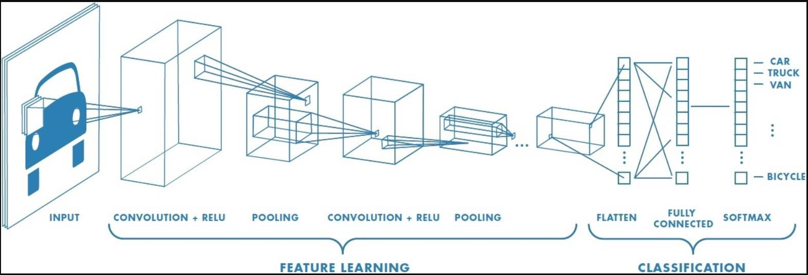

**34**

# VI.EXPERIMENTAL RESULTS

### CNN Accuracy Score:

It is difficult to compare the results of classifiers of traffic. Because the datasets being obtained, analyzed and the performance metrics applied are varies in each work.

There cannot be a single universally agreed metric in such a problem. There are many works which are carried out. on traffic management using neural networks, but the models employed are different to the one which is been presented here. A group of multilayer perceptron classifiers with error-correcting outputs is applied and results overall accuracy as 93.8%. Meanwhile, in another work on MLP with a particle swarm optimization algorithm is used to classify 6 labels with the accuracy of 96.9%.

In an entropy-based minimum description length of features as a pre-processing step to various algorithms such as C4.5, Naïve Bayes, SVM and KNN. Declaring a quality performance of the algorithms, achieving a accuracy of 93.2% to 98%.

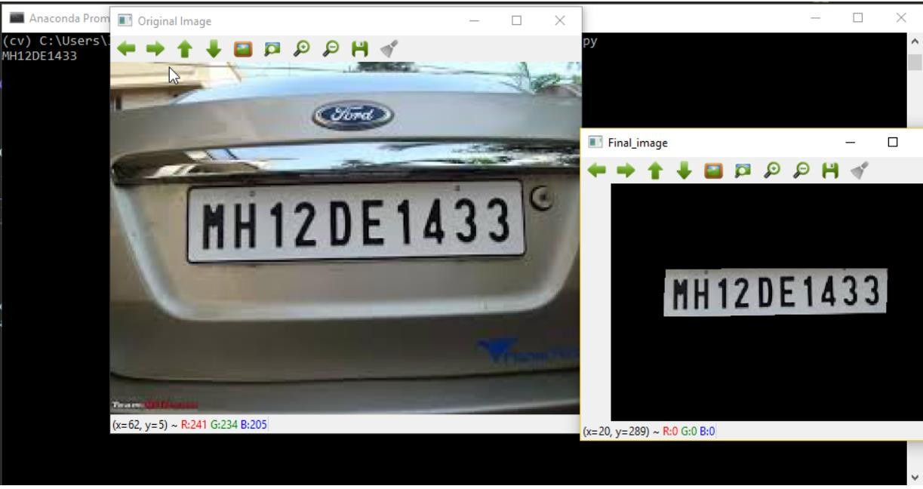

**35**

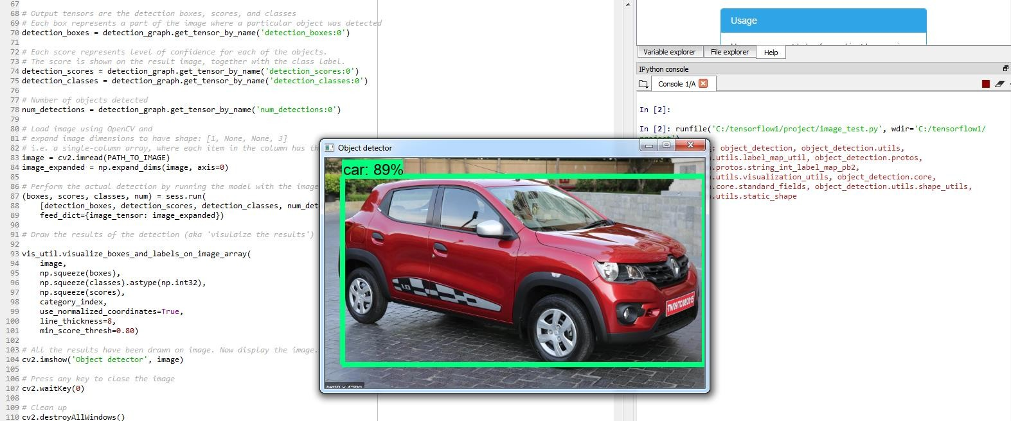

# VII.DISCUSSION OF RESULTS

The structure of the road network and the rapid growth of urbanization are becoming increasingly complex. The intersection delay is the main factor that affects the productivity of urban road traffic as the bottleneck of traffic growth. A fair signal control system could help relieve congestion on the highways. Suppose the privilege of preference for the emergency is not assured. In that case, the delay in traffic at the collision may increase, which could hardly indicate the reliable, safe and rapid output as a priority of public transport or any emergency vehicle. We have proposed the Convolutional neural network (CNN) based traffic management for emergency vehicles. CNN model is deployed in the Raspberry-Pi. CNN model will accept the video from the traffic road and take quick decision to allow the emergency vehicles. The proposed method improves accuracy over traditional image processing algorithm and reduces cost.

Overall accuracy is quite more improved. The objects are better identified irrespective of the background .the proposed method is less vulnerable to have false propagation over time. It would provide out a better output rather than previous approaches. It optimized traffic computer vision also helped out in providing accurate information like traffic density, freeway traffic count etc. This resulted in Better traffic management and improved road safety. Mainly ,this proposal would be beneficial in reducing traffic congestion .Relying on the number of vehicles ,data from the cameras, smart traffic signals can be adjusted to avoid crucial road traffics.

**36**

# 

# VIII.SUMMARY

After doing extensive research, we reached the conclusion that there are several drawbacks of earlier methods - Wastage of time by lighting green signal even when road is empty. Image processing removes such problem. Slight difficult to implement in real time because the accuracy of time calculation depends on relative position of camera. This project provides a solution to reduce traffic congestion on roads overriding the older system of hard coded lights which cause unwanted delays.

Reducing congestion and waiting time will lessen the number of accidents and reduces fuel consumption which in turn will help in controlling the air pollution. This will also provide data for future road design and construction or where improvements are required, and which are urgent like which junction has higher waiting times.

# 

# IX.CONCLUSION

We propose a technique that can be used for traffic control using image processing. Traffic density of lanes is calculated using image processing which is done of images of lanes that are captured using digital camera. According to the traffic densities on all roads, our model will allocate smartly the time period of green light for each road. We have chosen image processing for calculation of traffic density as cameras are very much cheaper than other devices such as sensors.

Traffic Management is an issue which impacts us almost daily. Use of technology and real time analysis can actually lead to a smooth traffic management. The common reason for traffic congestion is due to poor traffic prioritization. Let us take the scenario of Bengaluru. It is third most populous city of India. While the number of vehicles are increasing at a fast pace, the infrastructure in the city is not being able to match this growth. However, our solution to this problem is not limited to the Bengaluru city only. It can be used for other urban cities as well where traffic jams during rush hours are becoming a routine affair, especially in the internal sectors where long queues of vehicles can be seen stranded. Therefore, we have tried to address the problem with the help of our project wherein the focus would be to minimize the vehicular congestion. We have achieved this with the help of image processing that can be obtained from surveillance cameras and eventually to deploy a feedback mechanism in the working of the traffic lights where the density of the traffic would also be factored in the decision-making process.

**37**

# X.REFERENCE

1. [http://introtodeeplearning.com/.](http://introtodeeplearning.com/) Deeplearning
2. <https://keymakr.com/blog/what-are-bounding-boxes/-> image processing technique
3. Sheena Mariam Jacob, Shobha Rekh, Manoj G, J John Paul* Department of Electronics & communication Engineering, Karunya University [johnpaul@Karunya.edu.](mailto:johnpaul@Karunya.edu)
4. Alam, J.B., Jaigirdar, M. A. and Rahman, M.H. (1999). Analysis of Behavioral Value of Travel Attributes and Their Implications on Urban Transport Policies, Journal of Civil Engineering, I.E.B., Vol. CE 27, No. 1, 1999.
5. Arumala, J. O. And Akpokodje, E. G., 1987. Soil Properties and Pavement Performance in the Niger Delta. Quarterly Journal of Engineering Geology and Hydrogeology, Vol. 20, pp. 287-296.
6. Bailey, L., Mokhtarian, P. L., Little, A. (2008). The Broader Connection between Public Transportation, Energy Conservation and Greenhouse Gas Reduction. Report prepared as part of TCRP Project J-11/ Task 3 Transit Cooperative Research Program, Transportation Research Board submitted to American Public Transportation Association in [http://www.apta.com/research/info/online/land_use.cfm#i,](http://www.apta.com/research/info/online/land_use.cfm#i) accessed 17 April 2008.
7. Bartone, E; Branstein, J; Eigen, J. (1994). Urban Management Program toward Environmental Strategies for Cities, World Bank Technical Report.
8. Ewing, R. and Cervero, R. (2001). Travel and the Built Environment: A Synthesis. Transportation Research Record 1780, Washington, D.C: TRB, National Research Council.
9. Goldberg, M. A. (1970). Transportation, Urban Land Values, and Rents: A Synthesis Land Economics, 46, 2 (May), 153-162.
10. Mannering, Fred L.; Walter P. Kilareski; Scott S. Washburn (2004). Principles of Highway Engineering and Traffic Analysis. 3rd ed. NJ: John Wiley & Sons; 170 – 219.
11. Owen, W., 1964. Strategy for Mobility. The Brooking Institute, Transport Research Program, Washington D.C., 249p
12. Oyesiku, O. O. (2002). From Womb to Tomb. 24th Inaugural Lecture at Olabisi Onabanjo University on 27 August 2002. Ago-Iwoye: Olabisi Onabanjo University Press. 26

Polzin, S. E. (2004). Relationship between Land Use, Urban Form and Vehicle Miles of Travel: The State Of Knowledge and Implications for Transportation Planning. University of South Florida, Tampa; Florida Department of Transportation; Federal Highway Administration in <http://www.cutr.usf.edu/>pubs/TransLU%20White%20Paper%20Final.pdf

**38**

1. Queiroz, C and Gautam, S., 1992. Road Infrastructure and Economic Development: Some Diagnostic Indicators. Policy Research Working paper Series 921, The World Bank 37p.
2. Said, M. N. and Shah, M. Z. (2008). GIS as a Supporting Tool in The Establishment of Land Use- Road Density Model in [www.GISdevelopment.net.](http://www.GISdevelopment.net/)
3. World Bank, 1996. Expanding Labor-Based Methods for Road Works in Africa. Environmentally Sustainable Development Division, World Bank, Washington, D.C., 74p.

**39**